Test Case: tc003_SPX_Dev5_Crear_Requisicion_Spot_Tipo_Cobro_CC_Urgent
Step 1 - Enter username and password and click to button Enter : Credentials Entered
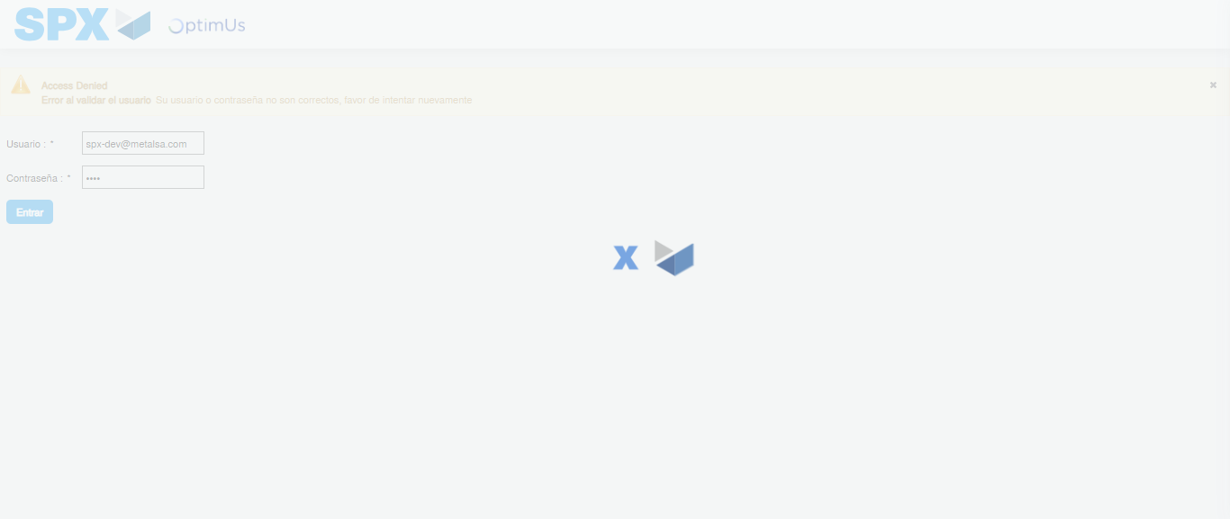Image file-name: QC_Testing-tc003_SPX_Dev5_Crear_Requisicion_Spot_Tipo_Cobro_CC_Urgent-1783358546648

Step 2 - Select to UEN and Access to Spot Buy Requisitions : UEN Correctly selected and Correct access
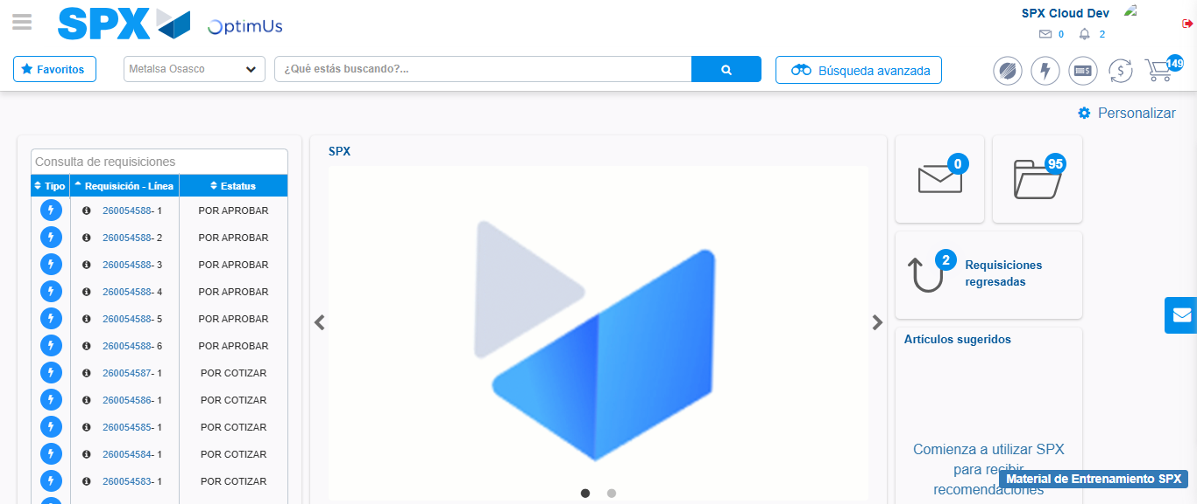Image file-name: QC_Testing-tc003_SPX_Dev5_Crear_Requisicion_Spot_Tipo_Cobro_CC_Urgent-1783358572832

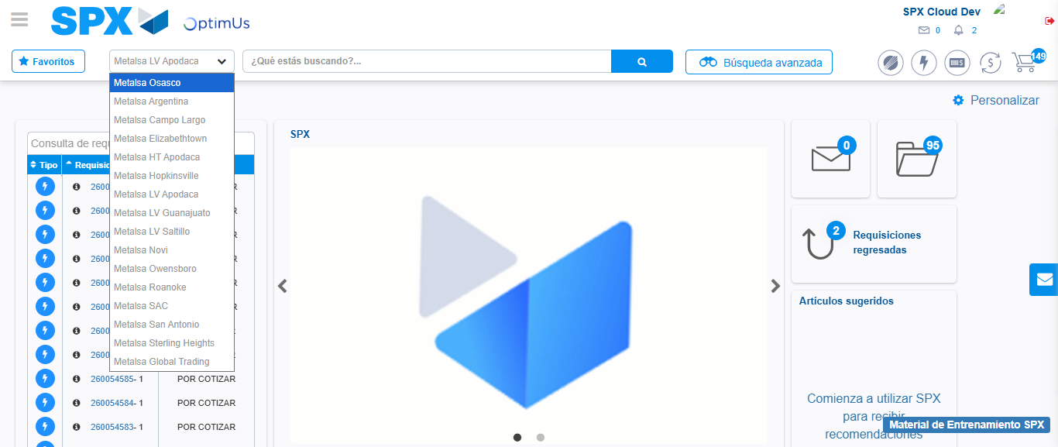Image file-name: QC_Testing-tc003_SPX_Dev5_Crear_Requisicion_Spot_Tipo_Cobro_CC_Urgent-1783358575737

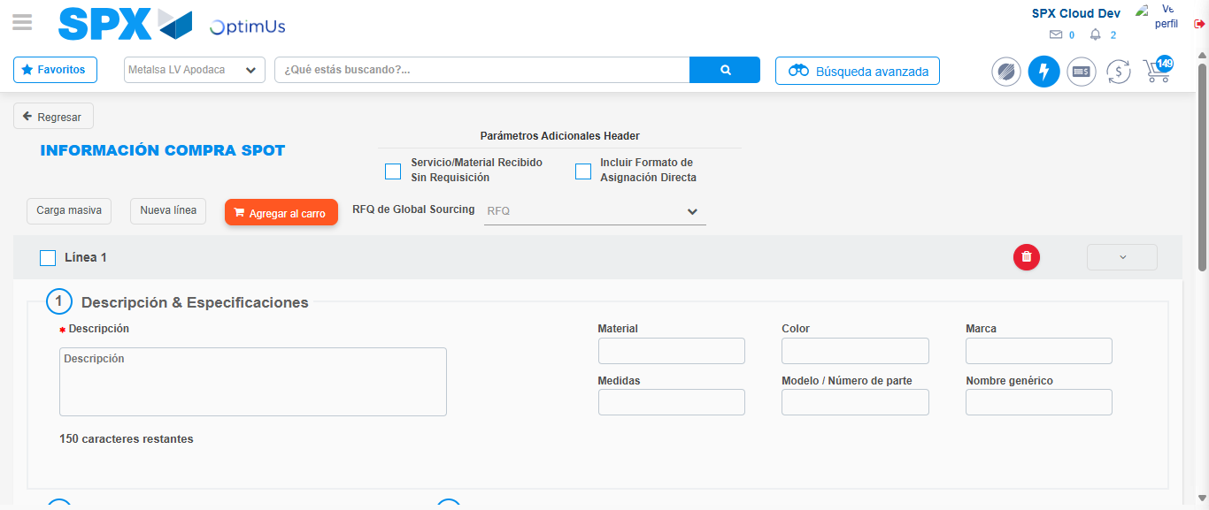Image file-name: QC_Testing-tc003_SPX_Dev5_Crear_Requisicion_Spot_Tipo_Cobro_CC_Urgent-1783358599963

Step 3 - Data Capture Spot Buy Requisition: Data captured correctly
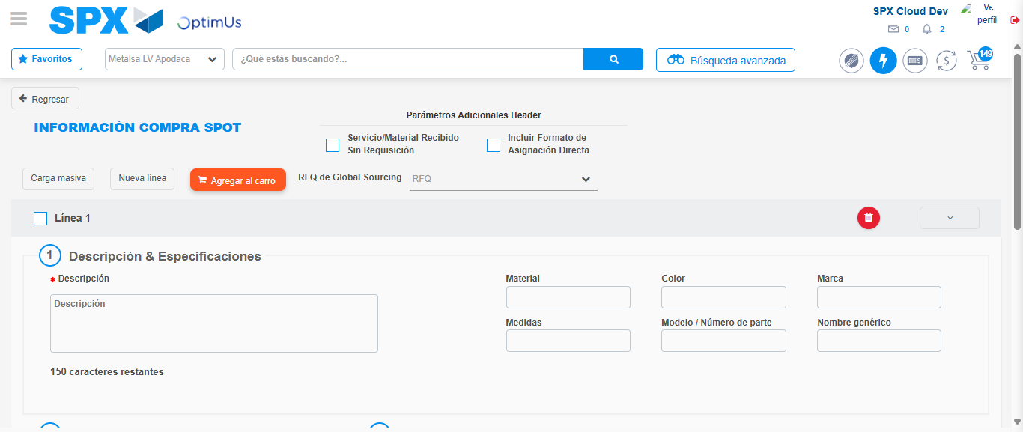Image file-name: QC_Testing-tc003_SPX_Dev5_Crear_Requisicion_Spot_Tipo_Cobro_CC_Urgent-1783358600202

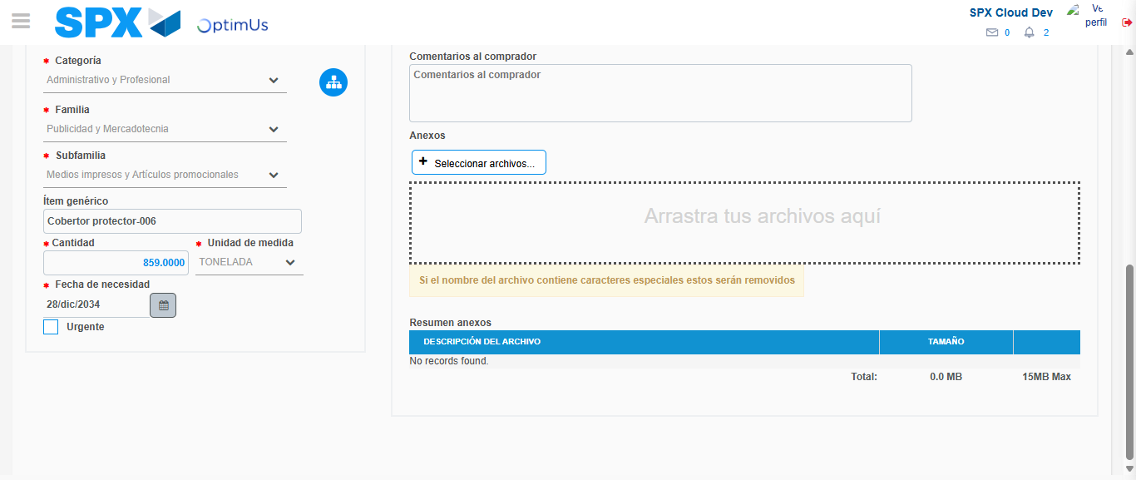Image file-name: QC_Testing-tc003_SPX_Dev5_Crear_Requisicion_Spot_Tipo_Cobro_CC_Urgent-1783358612024

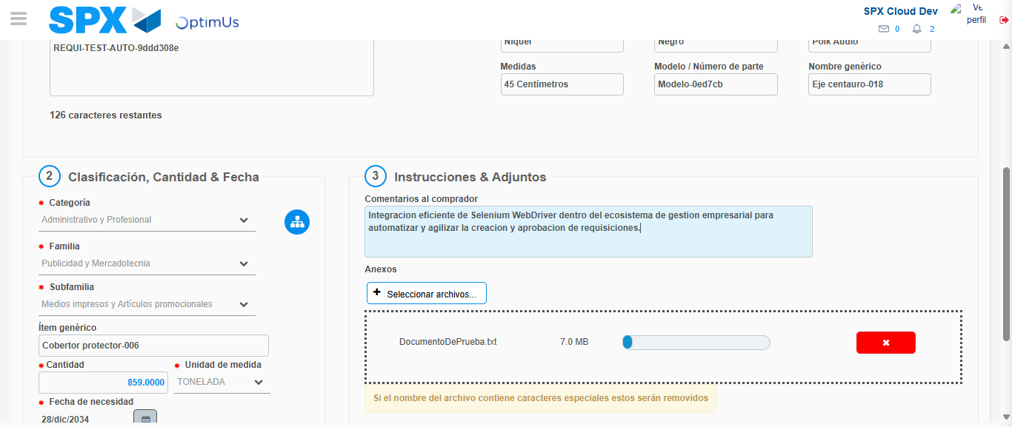Image file-name: QC_Testing-tc003_SPX_Dev5_Crear_Requisicion_Spot_Tipo_Cobro_CC_Urgent-1783358612972

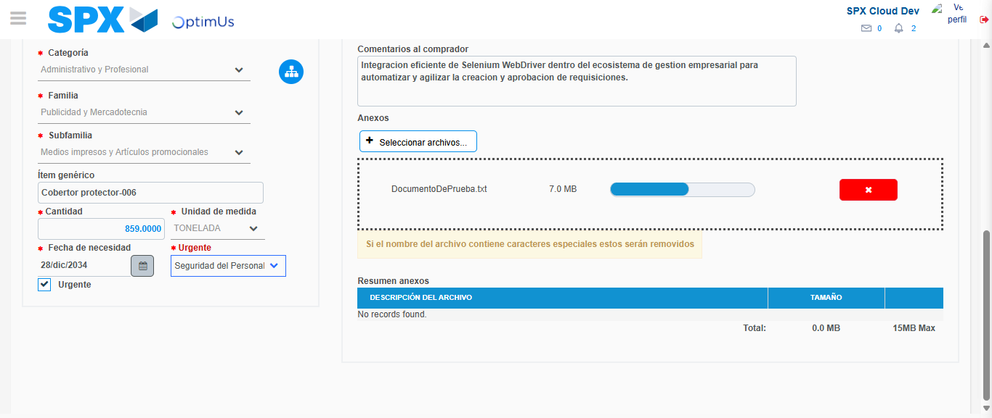Image file-name: QC_Testing-tc003_SPX_Dev5_Crear_Requisicion_Spot_Tipo_Cobro_CC_Urgent-1783358616365

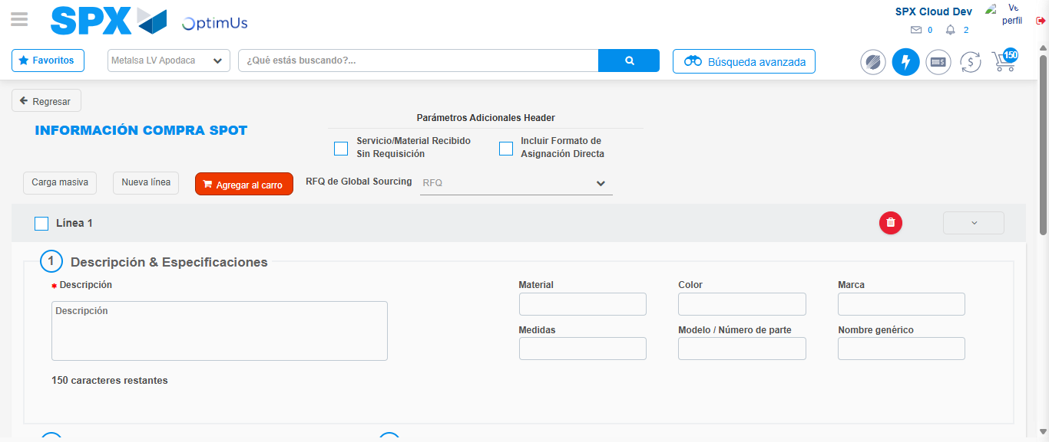Image file-name: QC_Testing-tc003_SPX_Dev5_Crear_Requisicion_Spot_Tipo_Cobro_CC_Urgent-1783358625932

Step 7 - Return to Main Page SPX : Return to Main Page SPX
Image file-name: QC_Testing-tc003_SPX_Dev5_Crear_Requisicion_Spot_Tipo_Cobro_CC_Urgent-1783358572832

Image file-name: QC_Testing-tc003_SPX_Dev5_Crear_Requisicion_Spot_Tipo_Cobro_CC_Urgent-1783358575737

Image file-name: QC_Testing-tc003_SPX_Dev5_Crear_Requisicion_Spot_Tipo_Cobro_CC_Urgent-1783358599963

Image file-name: QC_Testing-tc003_SPX_Dev5_Crear_Requisicion_Spot_Tipo_Cobro_CC_Urgent-1783358628209

Image file-name: QC_Testing-tc003_SPX_Dev5_Crear_Requisicion_Spot_Tipo_Cobro_CC_Urgent-1783358628390

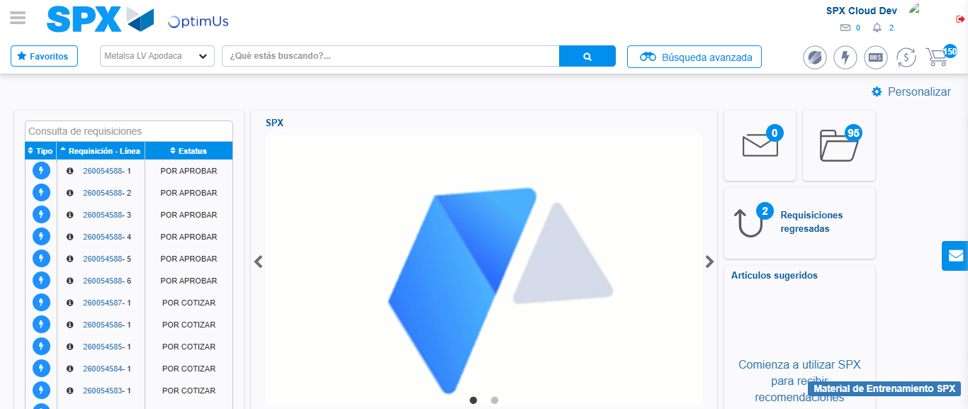Image file-name: QC_Testing-tc003_SPX_Dev5_Crear_Requisicion_Spot_Tipo_Cobro_CC_Urgent-1783358649769

Step 8 - Log Out : Log Out SPX
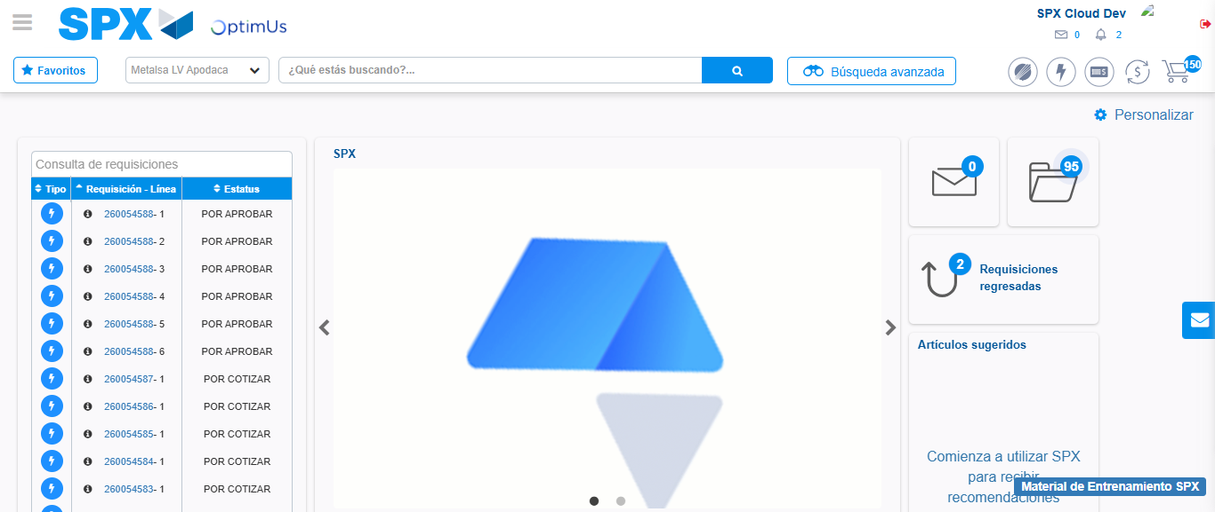Image file-name: QC_Testing-tc003_SPX_Dev5_Crear_Requisicion_Spot_Tipo_Cobro_CC_Urgent-1783358650179

